Lowe’s DIY Vids

1. How to blend a drywall patch
   1. After placing patch, apply joint compound. Feather at the edges.
   2. Sand down with fine-grit sandpaper
   3. Choose same paint gloss as existing wall
2. Lowe’s DIY: How to Repair Concrete
   1. Concretee basics:
      1. Concrete is a composite made out of several different materials. A mix of fine/coarse pieces is held together by a liquid cement binder
         1. Check your package instructions, but you’re generally looking for a “peanut butter” consistency
   2. Crack repair:
      1. Two types of cracks in concrete:
         1. Hairline crack
            1. 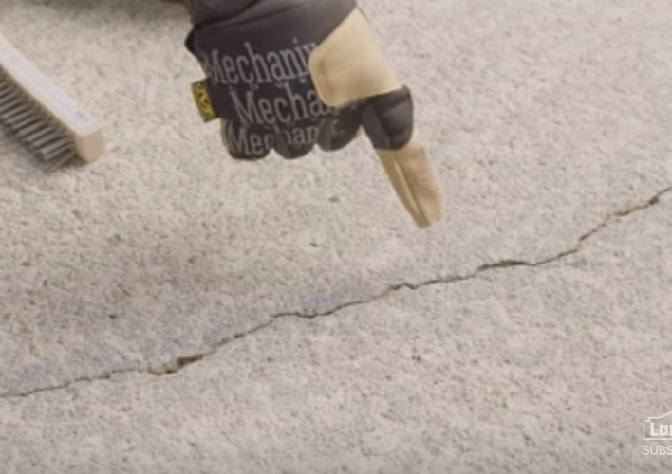
            2. Steps to repair:

Clear away any debris

Apply caulk gun with masonry crack filler

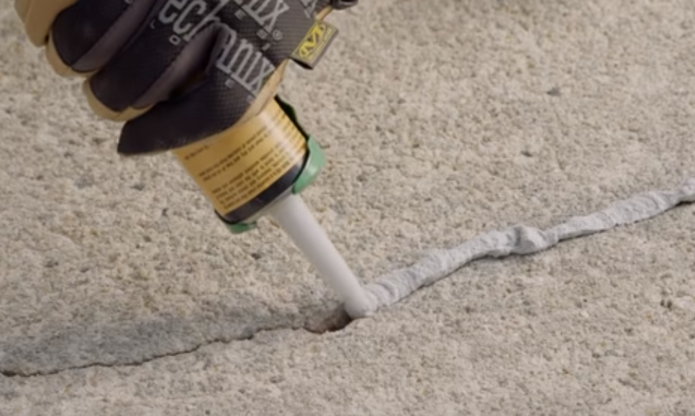

Smooth out with a putty knife

**Alternatively,** you can use a “vinyl concrete agent”

* + - 1. Wide crack
         1. 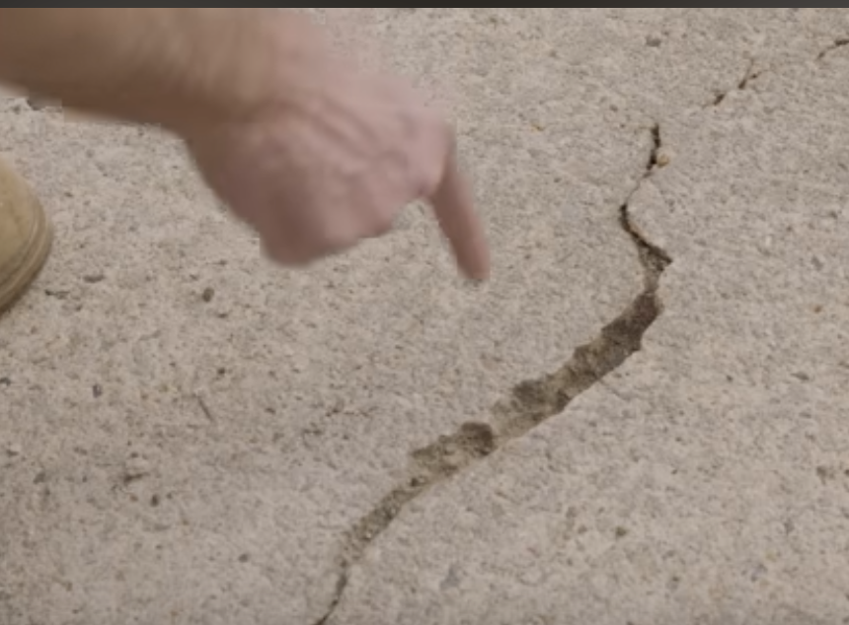
         2. Steps to repair:

Chisel out the bottom of the crack (you want bottom to be wider than the top, which will allow better setting of the material

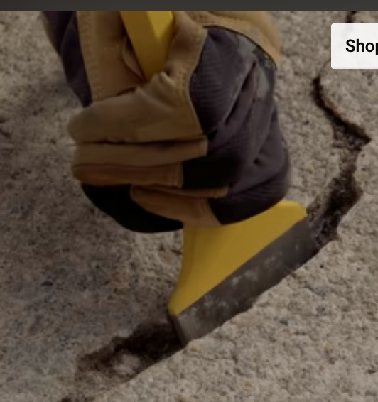

Clean debris with a wire brush, then wet the area

Fill in with a vinyl patching mix and a trowel:

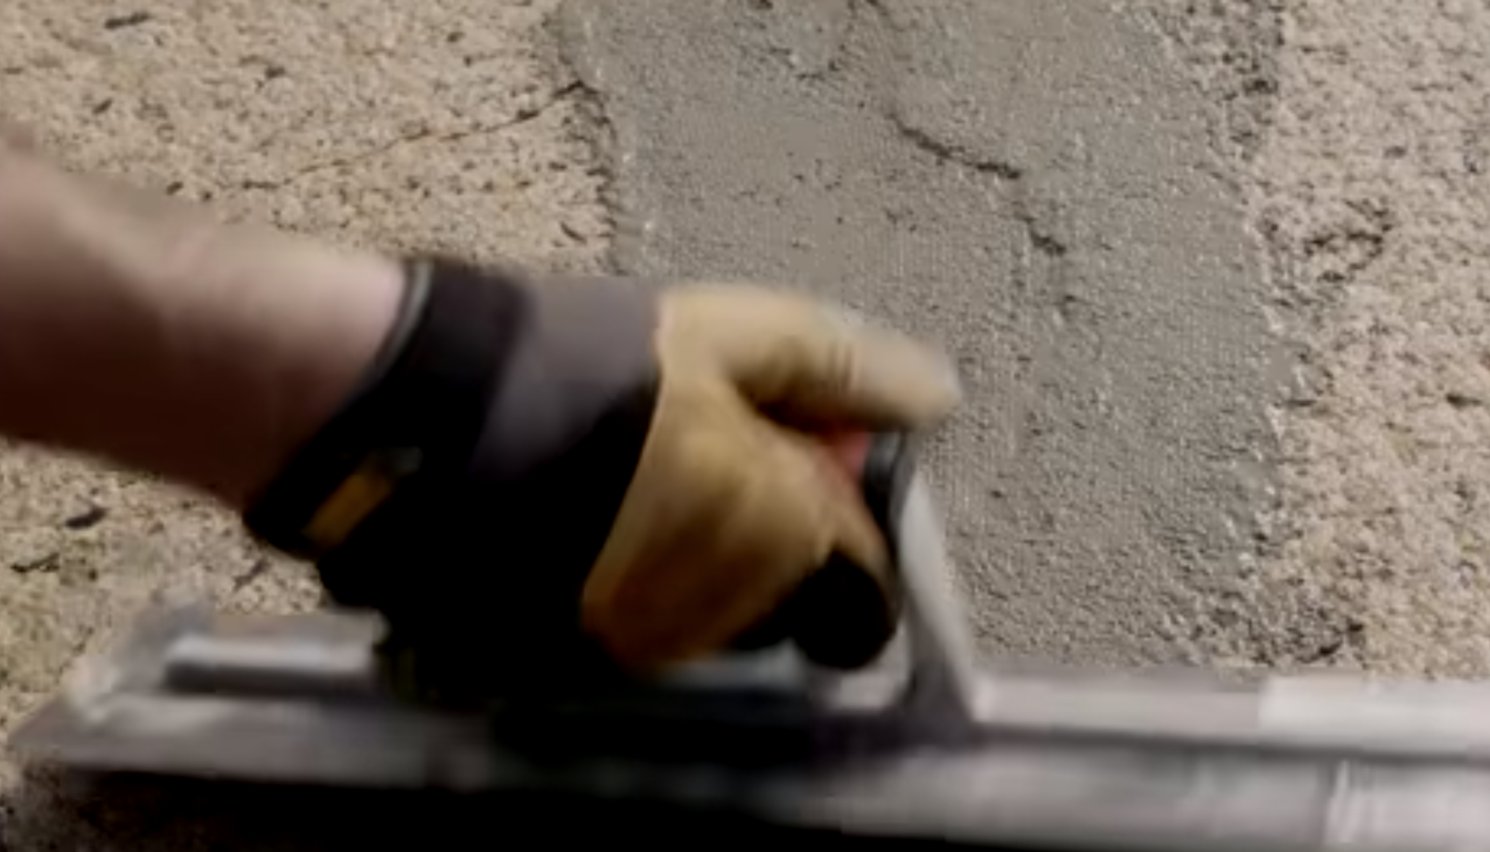

* + - 1. Edge damage:
         1. How to repair:

Clean out all debris/extra crap from the edge

Chisel away until you are left with *nothing b ut strong concrete*

After you’ve done this, consider using a **masonry bit** to create room for some rebar (metal dowel)

Make sure that you are applying a binding product to your rebar and that it is only sticking *halfway* out of the hole

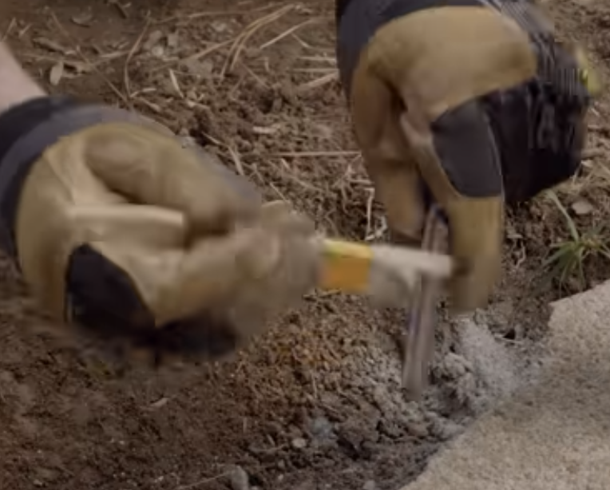

Apply that same binding product to the side walls of the broken concrete as well

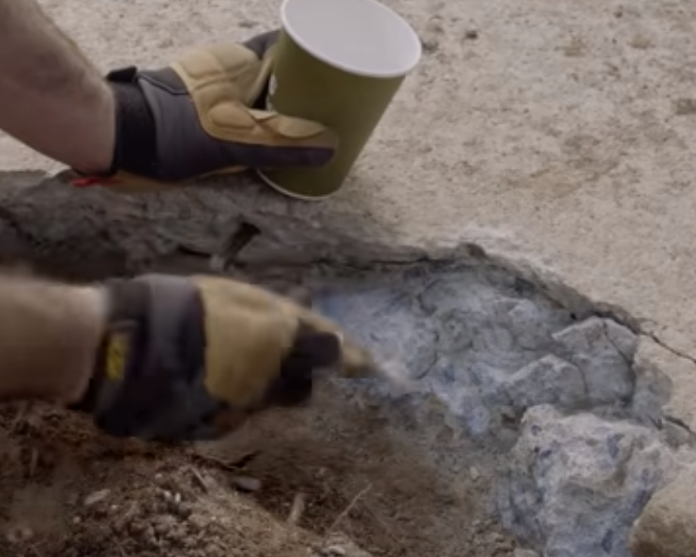

Mix up concrete with water and some binding product as well

Create a form with some scrap wood, then pour in your concrete/smooth it out, etc.

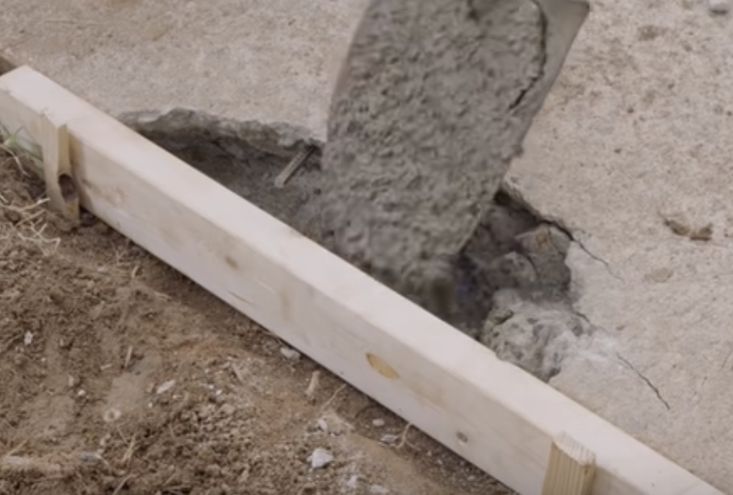

Brush over the top with a broom for a no-slip surface, then leave in place to dry for ~1 week

* + - 1. Section replacement:
         1. If you need to replace an entire section of concrete, then remove the entirety of the damaged area with chisel/sledgehammer, etc. and then clean for debris
         2. Create a form w/ scrap wood, ensuring that it is flush with the surrounding sessions:
         3. 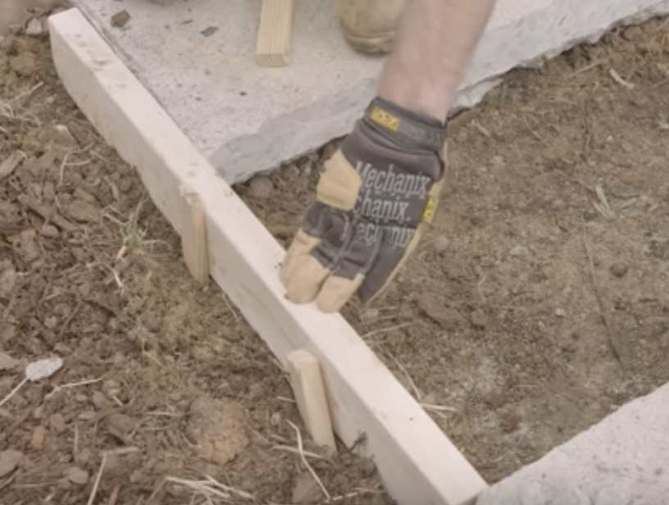
         4. Spray inside of the form with oil for a quick release
         5. Lay some sand and tamp it down:
         6. 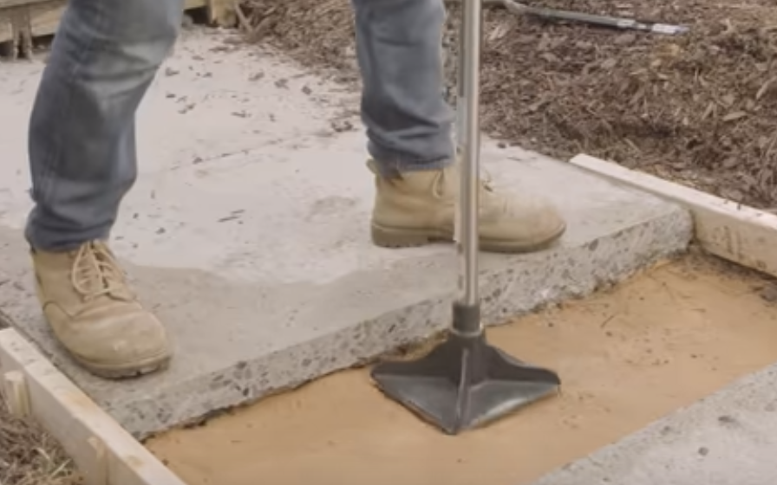
         7. Pour in concrete, smooth it out, etc. (“screeding”)
         8. Lightly place some plastic on top and let it dry for a few days. Then remove after a few days, and let dry for a couple more *without* the plastic.

1. Jigsaw tricks
   1. Assorted tricks:
      1. Cover shoe w/ tape to protect delicate surfaces
      2. Always check that blade is placed at 90 degrees
      3. Place a straight edge to make straight cuts
      4. If you’re worried about tear-out, turn the wood *show-side down* as tear-out typically occurs on the top.
   2. How to cut circles with a jigsaw:
      1. See the circle jig that they propose in the video…
2. How to cut down a tree:
   1. Note: This video only deals with *small* (i.e. diameter <= length of your chainsaw blade) trees. If you have a huge tree, one near a house, one that you’d like to fell opposite of its lean, etc. then consider calling a pro
   2. With the tree **on your left**, make a 70 degree cut in the direction you’d like the tree to fall:
      1. 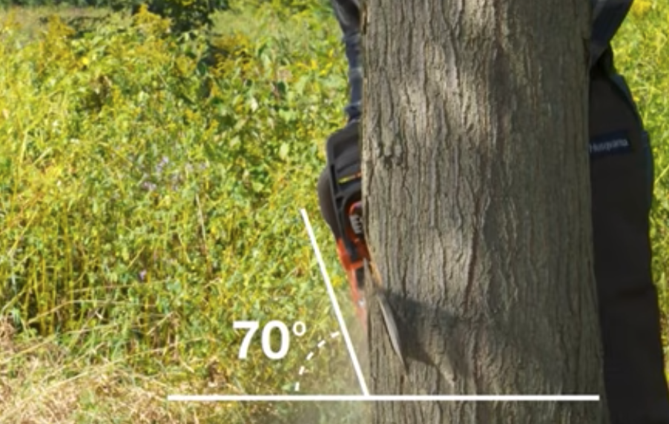
   3. Cut to a depth that is ~1/4 of the tree’s diameter
      1. 
   4. Cut perpendicularly to make a “felling cut”
      1. 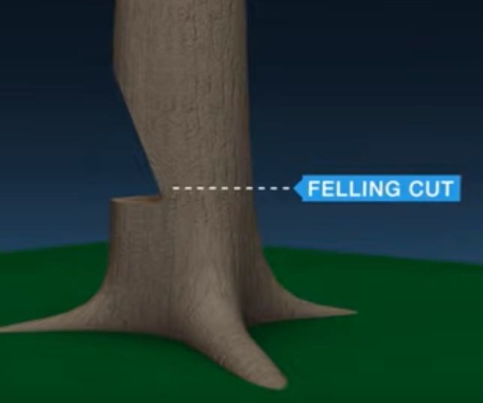
   5. Saw until you have enough room to insert a wedge:
      1. 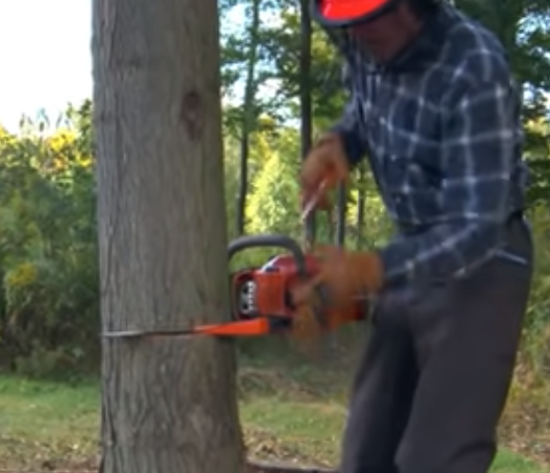
   6. Finish the cut, making sure that you can get out of the way along a pre-planned escape route:
      1. 
   7. Breaking down the tree:
      1. Taking off the limbs is called “limbing”
      2. Dismantling the trunk is called “bucking”
3. How to connect two wires:
   1. Always start by turning off the power:
   2. 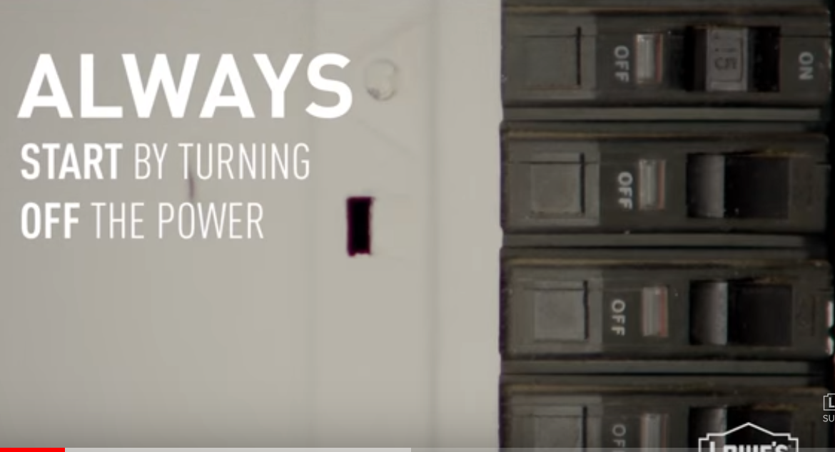
   3. 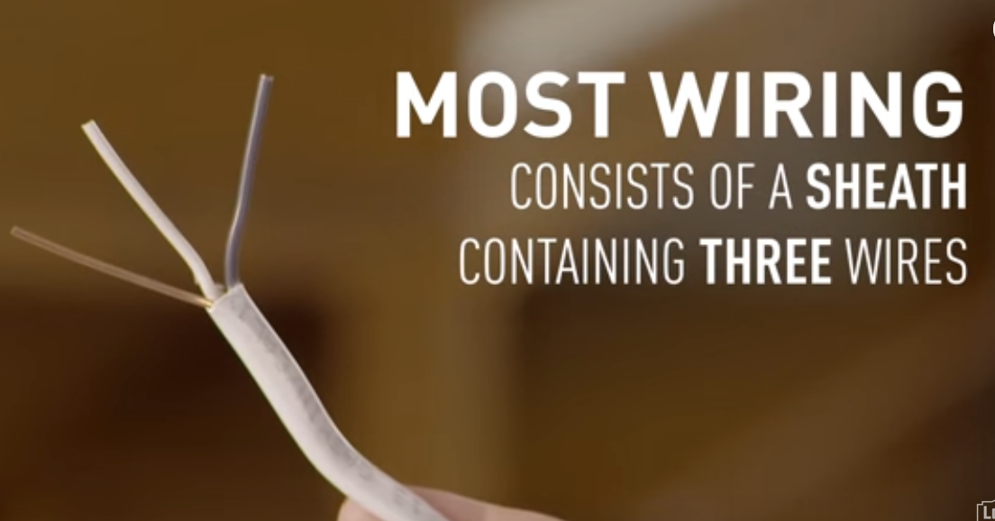
      1. Hot: Usually the **black** wire
         1. Some cables will also contain a second hot wire that is **red** in color
      2. Neutral: Usually the **white** wire
      3. Ground: Usually **bare** or **green**
         1. If the wires don’t look like this, then stop and call a pro
   4. Connect **like to like. Then:**
      1. Put bare wires side-to-side:
         1. 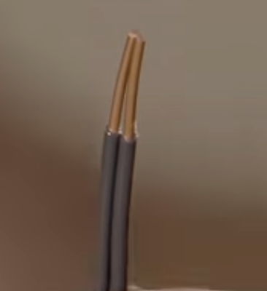
      2. Twist with a **wire connector**:
         1. 
      3. Wrap with electrical tape!
         1. 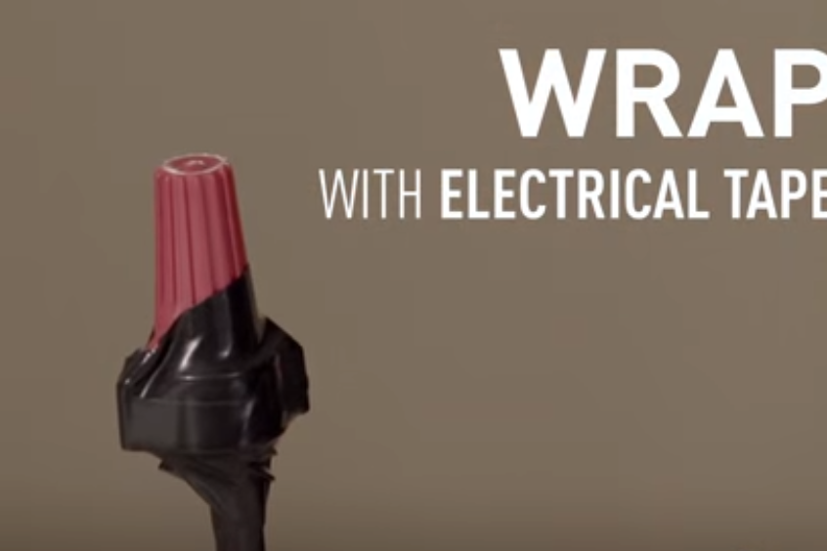’
4. How do I use shims?
   1. Shims are wedge-shaped pieces of wood or plastic
   2. They can be used to level cabinet bases, toilets, etc.
      1. You just hammer them in, cut w/ x-acto knife if need be
5. Cleaning and Using Reclaimed Wood
   1. Steps:
      1. Clean with scrub brushes, soap, and water
      2. Sand with increasingly fine grit sandpaper
6. How do I use a chisel?
   1. Stop cut:
      1. Creates a boundary for your chiseling
      2. 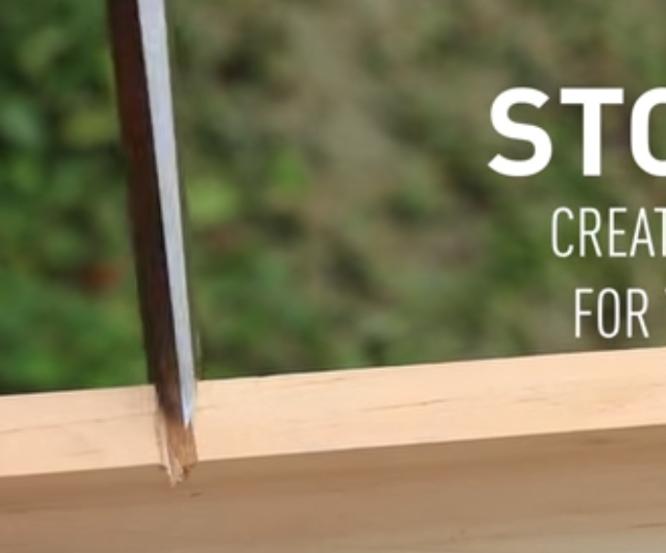
   2. Mortise cut
      1. Bevel side down, good for removing small amounts
      2. 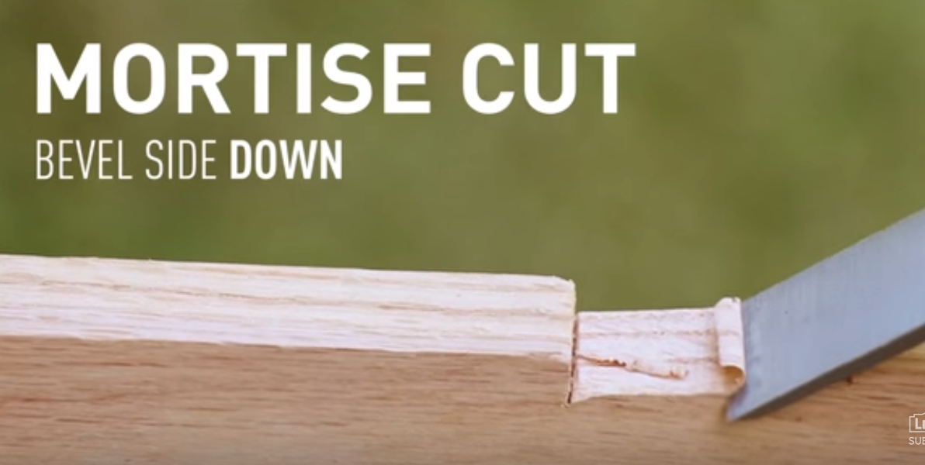
   3. Paring cut
      1. Small curving motions
      2. 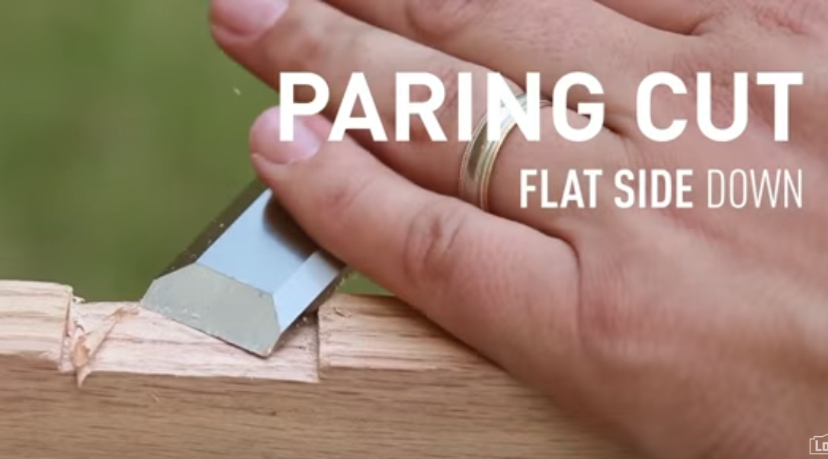
   4. Chop cut
      1. Bevel up; good for removing large amounts at once
      2. 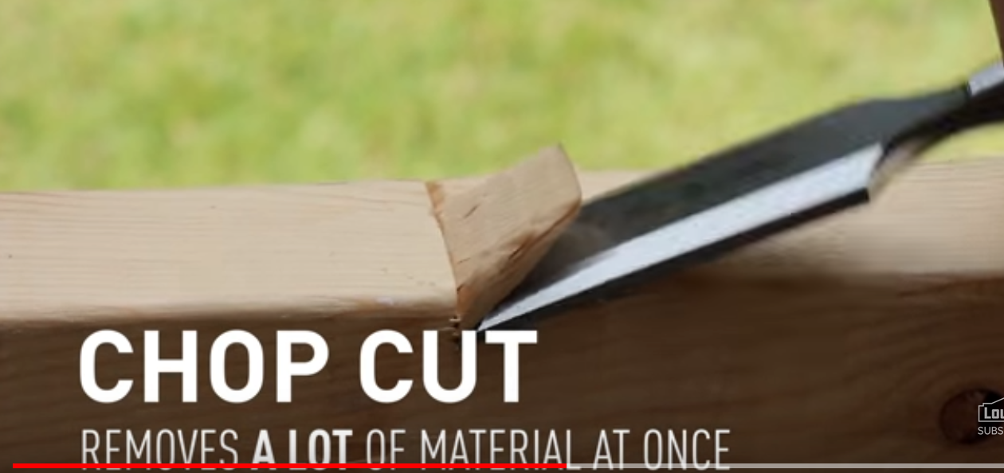
7. How to use a multimeter?
   1. Useful for testing voltage, resistance, and current
   2. Good for testing cords, fuses, lightbulbs, batteries, and more
   3. Steps:
      1. Unplug any items you test and turn power off at the breaker
      2. Choose between AC and DC
      3. Select voltage above the maximum for your circuit
      4. Touch red lead to one part of the circuit you are testing; touch the black lead to another part
8. How to strip a wire?
   1. Clamp, twist, and pull:
   2. 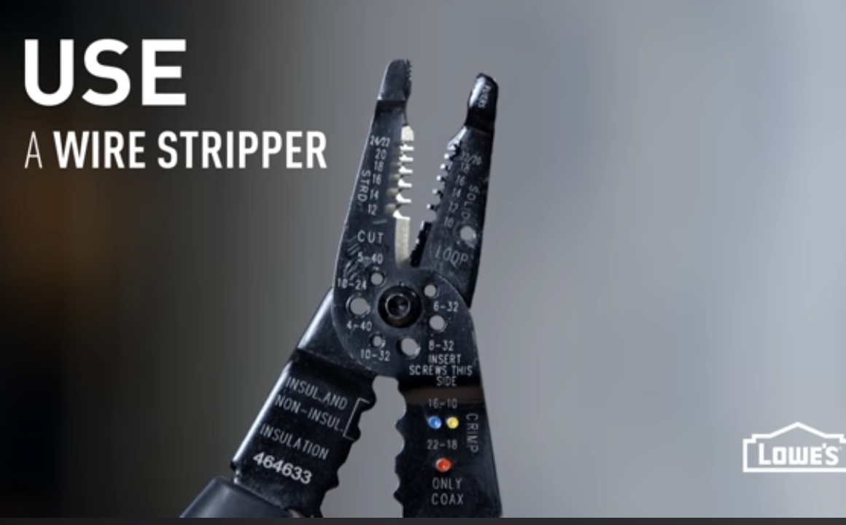
9. “What’s going on under my sink?”
   1. P-trap:
      1. 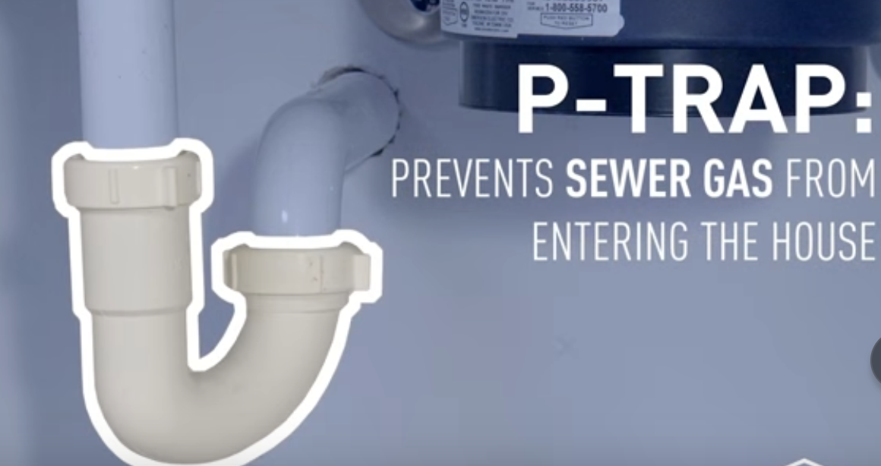
   2. Supply:
      1. 
   3. Dishwasher drain lines:
      1. 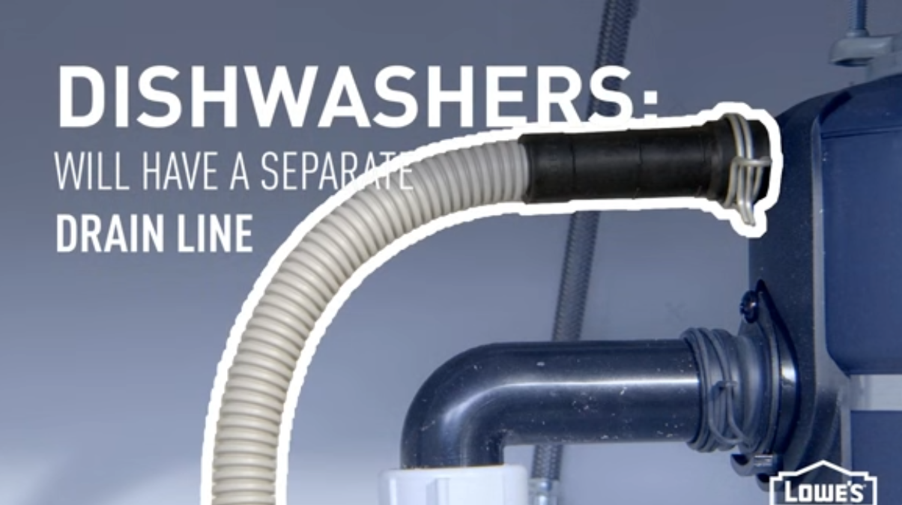
   4. Shutoff:
      1. 
   5. Waste lines:
      1. 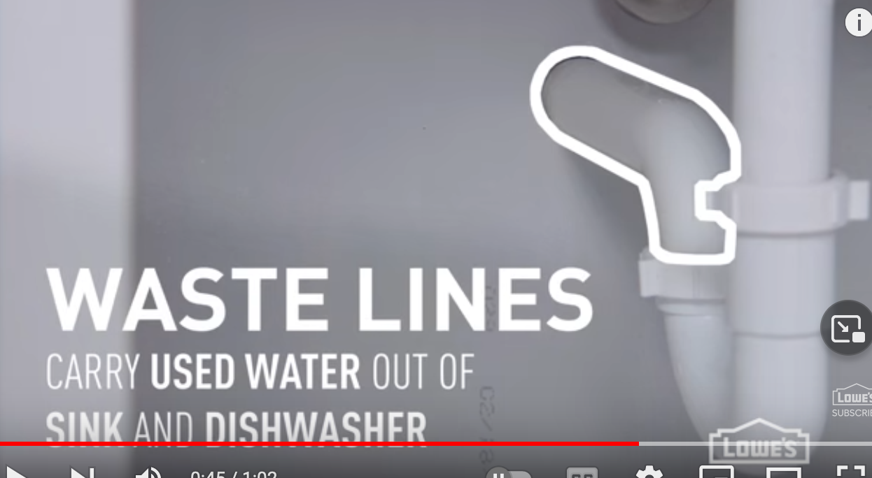
   6. Disposal:
      1. 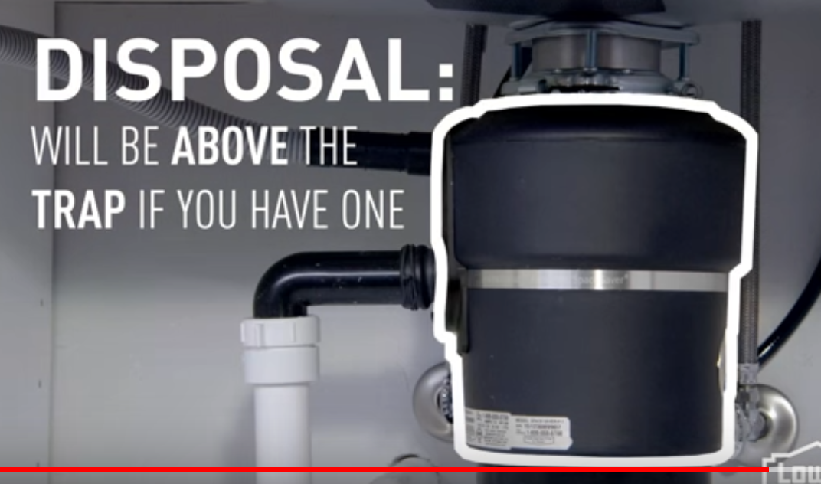
   7. What does a sump pump do?
      1. Sump: Shallow pit in the foundation where excess water gathers
      2. 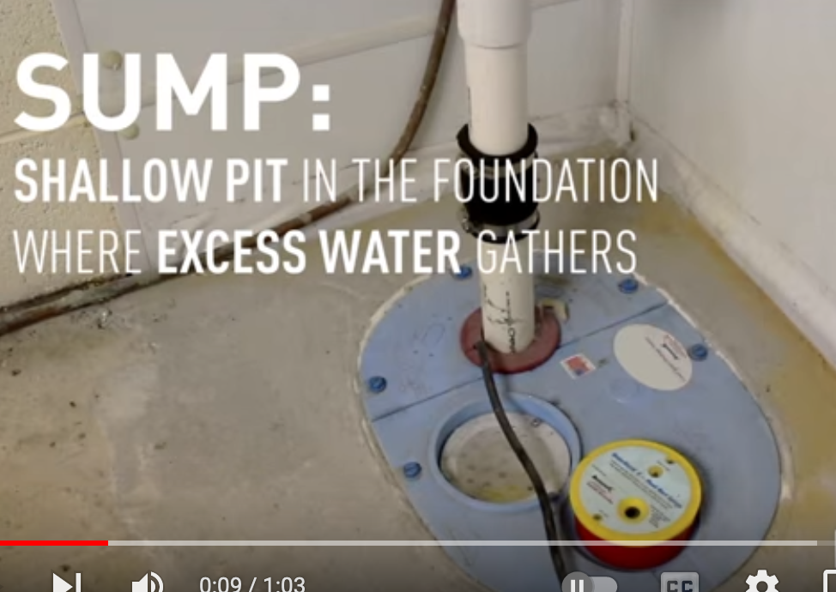
      3. Sump pumps are submerged in the sump to empty the water
      4. 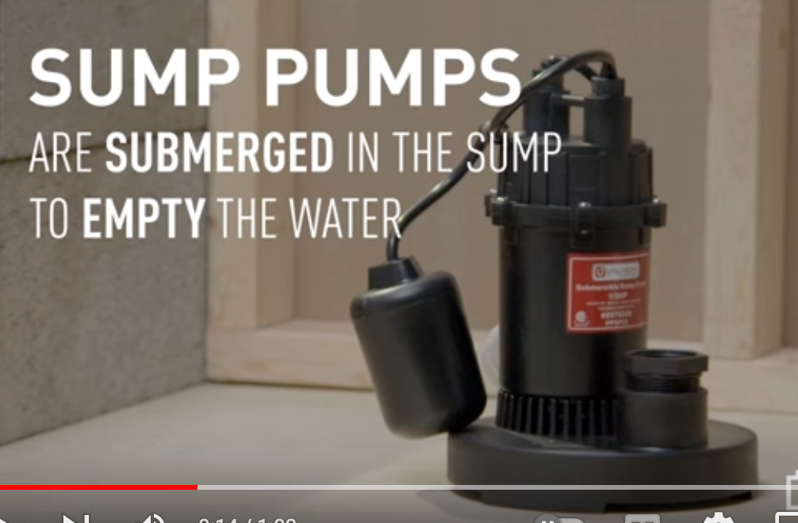
10. Plumb vs. level:
    1. 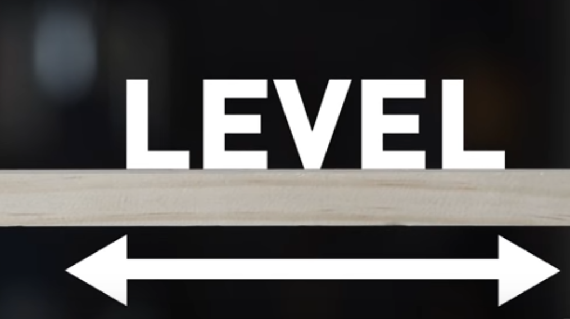
    2. 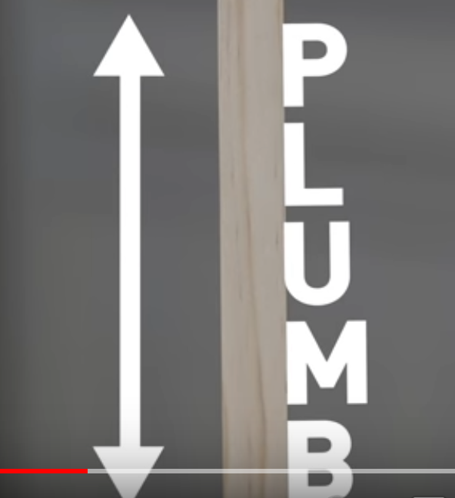
    3. 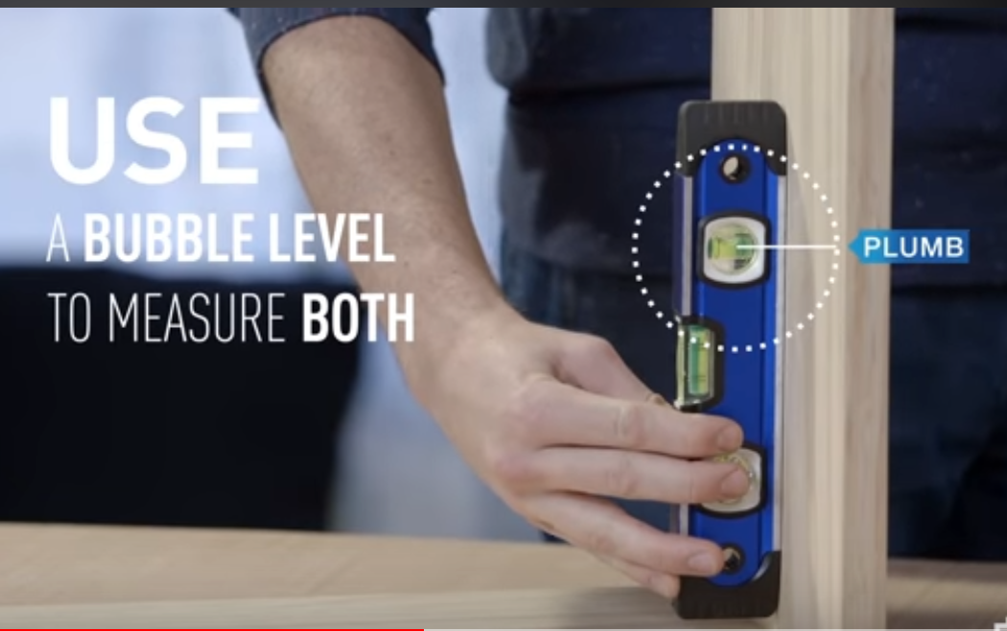
11. How do I drill a pilot hole?
    1. Driving nails and screws can crack wood so a pilot hole can be made to avoid this
    2. Choosing the correct sized drill bit for your pilot hole:
       1. Choose a bit that is the size of the **inner diameter** of your screw
    3. Note that you can use tape on *really* fine pieces to avoid splintered wood:
       1. 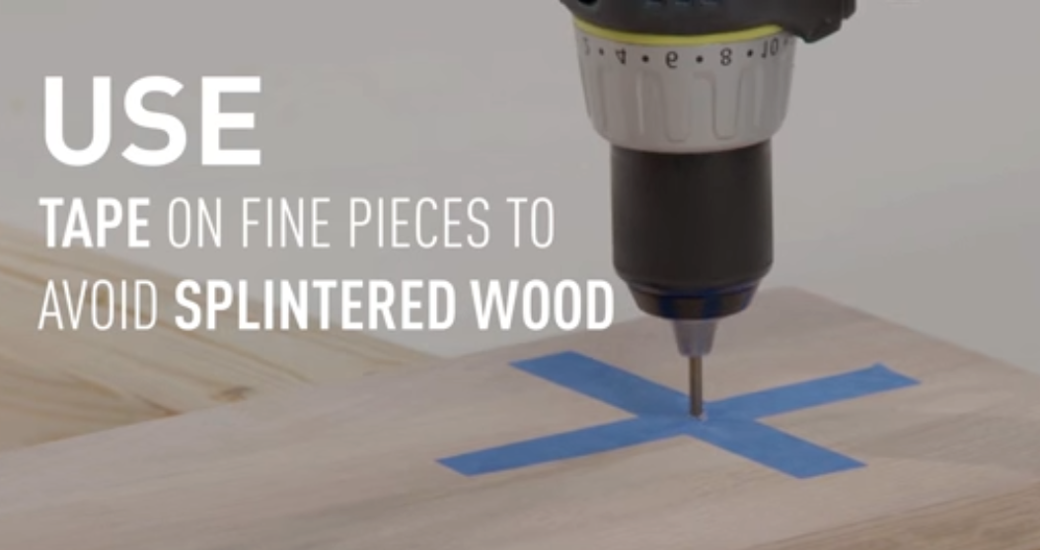
12. What hammer should I use?
    1. Curved claw: Good, all purpose
    2. Framing hammer: Heavier, more powerful
    3. Ball peen:
       1. 
    4. Rubber mallet: softer head for soft/delicate jobs
    5. Sledge: For destroying shit
    6. A variety of other specialty-specific hammers, too!
13. What’s in my breaker box?
    1. Circuit breakers will cut off power when tripped:
    2. 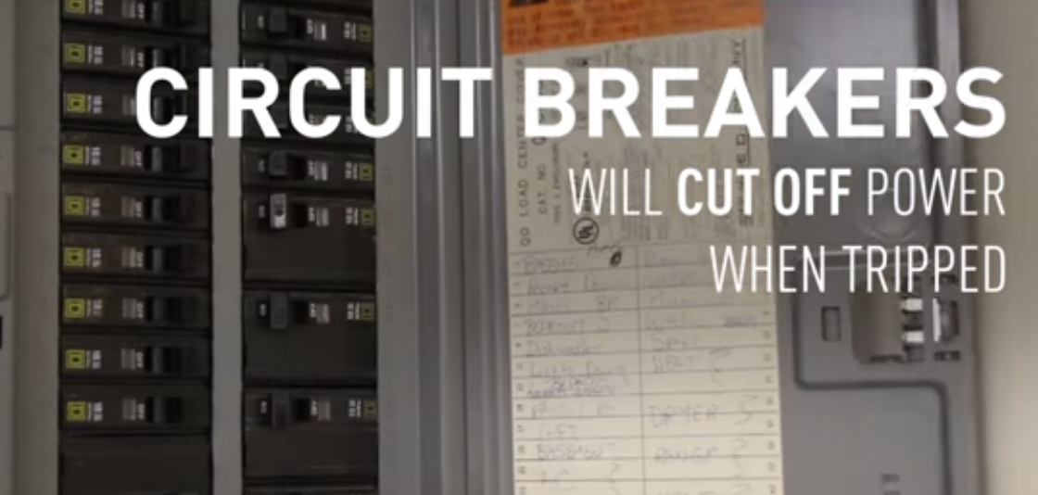
14. More router tips:
    1. Clean your bits every 4-5 uses with a blade/bit cleaner or lacquer thinner to remove glue or resin
    2. Use multiple passes to get the full profile of the bit
    3. Use a board or long level or actual router guide to act as a guide
15. Cordless drill basics:
    1. When you hear a “3/8” or “1/2 inch” drill, that’s referring to how wide the jaws can open up to accept a bit